Prediction and Analysis of Crime Against Women in India using Machine Learning
Manya Aggarwal
Computer Science & Engineering Department
Indira Gandhi Delhi Technical University for Women
Delhi, India
manya115btcse24@igdtuw.ac.in

Abstract
Crimes against women are a serious and complicated global issue. While official records often focus on offences like rape, dowry deaths, and honour killings, many other crimes, such as sexual assault, cyber crime, domestic violence, and various violent acts, also impact women but are often underreported. This study uses machine learning and data analysis to find patterns, hot spots, and predictive insights from a dataset of incidents involving female victims. The dataset includes details like the date and time of the crime, the type of crime, the victim’s age, the weapon used, and the case closure status. We performed Exploratory Data Analysis (EDA) to process and interpret the data, followed by several machine learning models to predict case closure through classification, estimate resolution time and crime frequency through regression, and identify geographic hot spots through clustering. The findings show that Delhi, Mumbai, and Bangalore have the highest rates of crime, with knives being the most common weapon. The data also indicates that crime peaks during midday hours in May and June. The Decision Tree Regression model reached an accuracy of 80.45% in predicting how long cases would take to close and 94.72% in estimating crime frequency. Although the models offered some predictive insights, we noted limitations in the available features. The study points out clear temporal and spatial trends that can help with resource allocation, focused policy efforts, and preventive strategies to improve women’s safety in India.

- Introduction

  - Background & Motivation

Violence against women or Crimes against women refers to physical, sexual and psychological harm or pain to women. This serious issue has been alarmingly increasing every year and has made headlines in almost every newspaper. Despite being recognised as a punishable offence on a global scale, incidents on crimes against women continue to rise. According to the report of the National Crime Report Bureau, domestic violence accounts for more than 30% of the crimes against women. In 2011, there were more than 228,650 reported incidents of crime against women, while in 2021, there were 428,278 reported incidents, an 87% increase. 65% of Indian men believe women should tolerate violence in order to keep the family together, and women sometimes deserve to be beaten. Most violence against women is not even reported to the police. A survey in January 2011 reported that 24% of Indian men had committed sexual violence at some point during their lives. According to the World Health Organisation (WHO), one in every three women experiences at least one form of violence. It could be physical, emotional or sexual violence. Such statistical reports call for an urgent need to address and alleviate these violent offences. Despite constant efforts by the Government of India to take preventive measures for women's safety, a recent annual report by the National Crime Records Bureau (NCRB) of India revealed a surge in the number of crimes by 15.3% in 2021 over 2020 and 4% in 2022 than the year 2021. This study is motivated by the need to identify patterns and draw meaningful conclusions that can assist policy makers and people in women's safety to take effective actions.

  - Problem Statement
In India, women are revered as goddesses in tradition, yet in reality these very deities are desecrated through the rising tide of crimes against women.The numbers of violent crimes in India especially those against women, including rape that are reported in official statistics are increasing with each passing year.This violence thrives within a milieu of steady economic growth, and increasing inequality between the rich and poor in Indian society; India's GINI coefficient, which has increased from 0.32 to 0.38 in the last two decades, is evidence of that . India's new riches and development strides as witnessed by its GDP growth from $450.42 billion in 2000 to $1841.7 billion, seem to bear no fruit for its women. In 2012, the crimes against women reported by official statistics increased by 24.7%, compared to those reported in 2008 . Ranging from the so-called eve-teasing and outright sexual harassment on the street or workplace, to harassment for dowry, molestation in public transport vehicles, and the often-reported rape, these crimes against women reflect the vulnerability and deep-rooted problems related to the position of women in Indian society. Out of 28 states, 10 states reported more than 10,000 cases of crime against women in 2011, putting states with both high and low HDI (Human Development Index) and literacy rates in the list; probably an indication that education and economic growth alone do not influence the occurrence of these crimes and points towards socio-political and cultural factors. This can be further observed in the National Crime Records Bureau (NCRB) statistics, which show that cruelty by a husband or his relatives (46.8%) and dowry-related crimes (7.1%) account for more than half of the crimes against women. With increased incidence and visibility of these gruesome crimes, there is an urgent need to address this problem at multiple levels of Indian society, including professional, familial and social settings.

  - What is the research gap or challenge?

Hidden crimes are not reported and not registered, and therefore do not appear in police statistics. There are many reasons why people do not report to the police—for example, they may not think the offence was serious enough, they may not trust the police, they may feel the police will not or cannot help, or they may fear consequences for the perpetrator. Violence against women is very much a hidden crime; it often takes place in private and intimate spaces, with the perpetrator being someone the victim knows. Societal attitudes and a lack of support further prevent victims from seeking help.
Public spaces such as streets, bus stands, railway stations, parks, and other community areas are meant for everyone to access and enjoy. Yet, for many women, these become scenes of harassment. Every day experiences of systematic assault on women’s fundamental right to free movement and personal dignity are a major concern.
Sexual harassment in public places is unwelcome, unsolicited behaviour of a sexual nature, including staring, gesticulating, touching, passing comments, and trailing. While these may not seem severe, they can be extremely upsetting, leaving women feeling ashamed, humiliated, or frightened.
Working women are no exception. In fact, they often face backlash when stepping into roles traditionally dominated by men, especially in the organised sector. In the unorganised sector, harassment is also widely prevalent. Studies reveal that sexual harassment remains endemic, often hidden, and present across all kinds of organisations, with 40–60% of working women experiencing harassment at their workplace.
Domestic violence against women (VAW) is another pressing issue that often remains latent due to underreporting and entrenched social norms that disadvantage women. Despite the existence of legal acts and policies aimed at gender equality and the elimination of VAW, many offences remain concealed, perpetuating a cycle of abuse and silence.
Research highlights this gap clearly. A study conducted in Kazakhstan, using two surveys and official data from the Committee on Legal Statistics and Special Records (2018–2022), found that there is a low probability of reporting domestic VAW to the authorities. This underscores a critical gap in awareness, trust, and access to effective legal and support systems.

1.4 Clear Articulation of What This Work Addresses
This work tackles the pressing problem of crimes against women in India. It uses data analysis and machine learning to find patterns, predict trends, and reveal insights from crime data. Unlike traditional studies that depend only on official statistics, this research combines exploratory data analysis, classification, regression, and clustering models to:

- Predict whether cases are likely to be closed or remain pending.
- Estimate how many days it takes to close a case.
- Identify crime hotspots in major Indian cities.
- Analyse time, location, and weapon-based patterns to help with targeted prevention.

By prioritising predictive insights over descriptive statistics, this study supports stronger crime prevention strategies. The findings aim to help policymakers, law enforcement, and women’s safety groups create effective interventions, allocate resources, and run awareness campaigns.

  - Objectives / Research Questions

The main goal of this research paper is to predict and understand crime against women in India using machine learning techniques. It focuses on finding high-risk areas and crime trends. The study aims to provide helpful insights for law enforcement agencies, policymakers, and women’s safety organisations to carry out targeted interventions.

Research Objectives:

- Identify crime-prone areas in India where security measures can be increased for women’s safety.
- Analyse trends of crimes against women over time, including the time of day, month, and seasonal changes.
- Examine socio-demographic and situational factors, such as victim age, weapon use, and type of crime, that influence crime occurrence.
- Apply machine learning models, including Classification, Regression, and Clustering, to predict case closure chances, estimate resolution time, and spot crime hotspots.
- Generate data-driven recommendations for resource allocation, policy planning, and awareness campaigns focused on reducing violence against women.

Research Questions:

- Which regions and cities in India have the highest rates of crimes against women?
- What are the time patterns for these crimes, including time of day, month, and season?
- Can machine learning methods accurately predict how long it takes to close a case or the chances of closure?
- What patterns emerge regarding crime type, victim demographics, and the weapons used?
- How can predictive insights lead to better security measures and preventive strategies?

2 Literature Study
Sr. No. | Title | Author(s) | Publication / Source | Year | Methods Used | Key Findings/ Limitations
1 | Exploring Crime Against Women in India: Socio-Economic and Spatial Trends | Jumi Aktarun Islam and Mrinal Saikia | Pressto, Adam Mickiewicz University Press | 2025 | Statistical analysis, spatial mapping | This research focuses on finding a relationship  between crime rates and socio-economic indicators such as literacy ,GDP.
2 | Crimes Against Women in India: Trends, Challenges, and Empirical Insights | Tanvi Saxena | SPRF India | 2024 | Analysis of NCRB & NFHS data, policy review | Recorded cases rose by 4% (2021–2022); significant underreporting, urban–rural and state differences; most cases relate to domestic abuse, highlighting limitations of official crime data.
3 | Addressing Violence and Rape Against Women in India: Statistical Realities and Interventions | Nasser Ul Islam and Aadil Hussain Wagay | SAGE Journals | 2025 | Statistical analysis, policy assessment | Rajasthan, UP, and MP lead in reported rape cases; stresses need for state-level and national intervention; based mostly on NCRB data from 2022.
4 | Crimes Against Women in India: Types, Trends, and Policy Gaps | Not specified | Smile Foundation | 2025 | Data analysis, policy review | 12.9% rise in crimes per 100,000 women (2018–2022); major categories: domestic violence and sexual assault; data quality issues and gaps in existing response policies.
5 | Mapping the Dynamics of Crime Against Women in India | Suman Kumari, Naveen Kumar and Anuradha Sharma | Journals OpenEdition | 2025 | Spatial and temporal analysis | NCRB data shows a 15.3% crime rise in 2021; persistent underreporting and need for improved policy action noted, using spatial crime mapping.
Table 1

3 Methodology

  - Datasets
The dataset utilized in this study was sourced from the Kaggle website datasets named Indian crime dataset, which is made available to the public and compiles numerous crime records (such as sexual assault, domestic violence, kidnapping, cyber crime, extortion, fraud etc.) This dataset encompasses incident-level features, including Report Number, Date Reported, Date of Occurrence,Time of Occurrence, City, Crime Code, Crime Description,Victim Age, Victim Gender, Weapon Used, Crime Domain, Police Deployed, Case Closed, Date Case Closed.

Technologies Used:
- Programming language- Python
- Pandas(for data manipulation)
- NumPy(for numerical computation)
- Matplotlib/Seaborn(for data visualizations)
- Sci-kit Learn( for building and applying machine learning models)

  - Preprocessing

Before conducting analysis, several preprocessing steps were performed to ensure data quality, reliability and consistency:

- Data Cleaning
The first step for creating any ML project is to understand the data well , which is crucial for gaining meaningful insights. This is being carried out concurrently with data cleaning, which includes converting dates datatype into the datetime datatype for time-based analysis and infinite values into missing values,if any ,to remove them easily. Key tasks that were performed include Handling missing values, handling outliers through Box Plot ,Correcting errors , checking and handling duplicate records in the dataset to avoid redundancy.

- Label Encoding
Categorical encoding is the process of converting categorical variables into numeric features.It is an important and necessary feature engineering step as Machine Learning Models basically generates a formula as a solution. So it is useful to interpret and work with categorical data effectively. This study incorporates a label encoder from sklearn.preprocessing module to encode columns with object datatype (like City, Crime Description, Weapon Used, Crime Domain, Case Closed)

- Normalization and Scaling
Scaling data is crucial in machine learning because it ensures that all features contribute equally to the model's learning process.Preventing features with larger magnitudes from dominating and leading to faster and more accurate model training. For standardization, we used a Standard Scaler from sklearn.preprocessing module , which is a tool that transforms data in a way such that each feature has a mean of 0 and standard deviation of 1. This is also known as z-score normalization.
The formula is
𝑥_{scaled} = $\frac{ (x-mean) }{std_dev}$
- Feature Engineering:
This involves transforming existing features of a dataset into new , more impactful and meaningful features , which can be beneficial in identifying patterns or enhancing accuracy of models. Some issues regarding key takeaways were addressed by adding 'Day of week' from 'Date of Occurrence' to capture weekly patterns in crime, extracting hour from the 'Time of Occurrence' and month from the 'Date of Occurrence' to visualize crime frequency by Hour and Month.

  - Exploratory Data Analysis

This study utilizes EDA to fully understand the data and learn its features.
To examine the univariate analysis, we incorporated histograms of numerical columns of the dataset and for categorical columns, plots like bar plot, count plot, pie chart yielded significant findings.
This study also examines bivariate analysis on both raw and derived features. This analysis provided key discoveries that helped in further predictions.

Univariate Analysis
Univariate analysis examines the distribution, centrality, and frequency of its variables in the dataset. The following visualizations represent some highlights:
  - Victim Age Distribution: The histogram indicates a somewhat uniform distribution across ages, but with most victims falling around a mean age of about 44 years, thereby indicating that middle-aged victims are more commonly reported.
  - Crime Code Distribution: The plot suggests that crimes are spread almost uniformly across different crime codes, except for a few codes which are somewhat more frequent than others, supporting the conclusion that a variety of crime types are observed and reported.
  - Police Deployed: On average, police deployed ten officers per case, and consistent response levels are striking throughout all cases; however, in assessing the differences in officers deployed, no consideration of the severity of crime is made. Further research could consider the severity of crime.

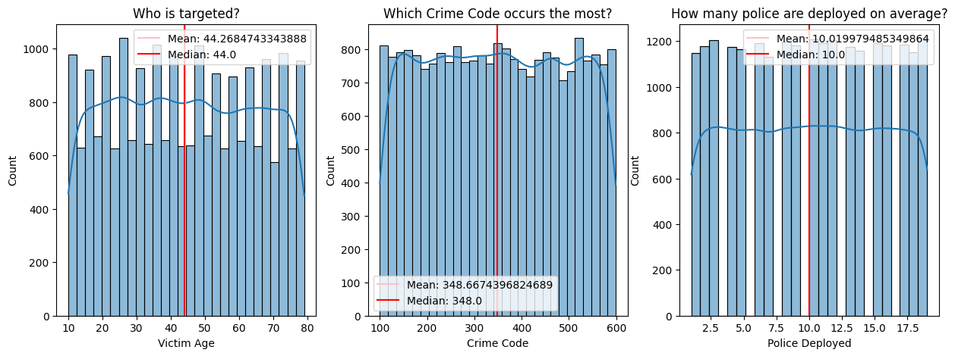
FIG. 1 - Victim Age Distribution; Crime Code Distribution; Police Deployed
- Top 10 Crime Cities: Cities including Delhi, Mumbai, and Bangalore have the highest crime rates, which suggest urbanisation is more susceptible to crime.
- Most Occurring Crimes: Most crimes are committed due to vandalism, fraud, and burglary, which indicates crime is happening more frequently concerning property/financial.
- Most Common Weapons Used: The analysis reveals knives are the most used weapon, followed by explosives and poison.
- Crime Domain Distribution: The pie chart indicates violent crime (28.79%) is a major domain category, while motor vehicle accidents and fire deaths account for less.
- Case Closure Rate: There is an almost 1:1 ratio of “closed” to “not closed” case status which shows law enforcement action is effective, but needs improvement.

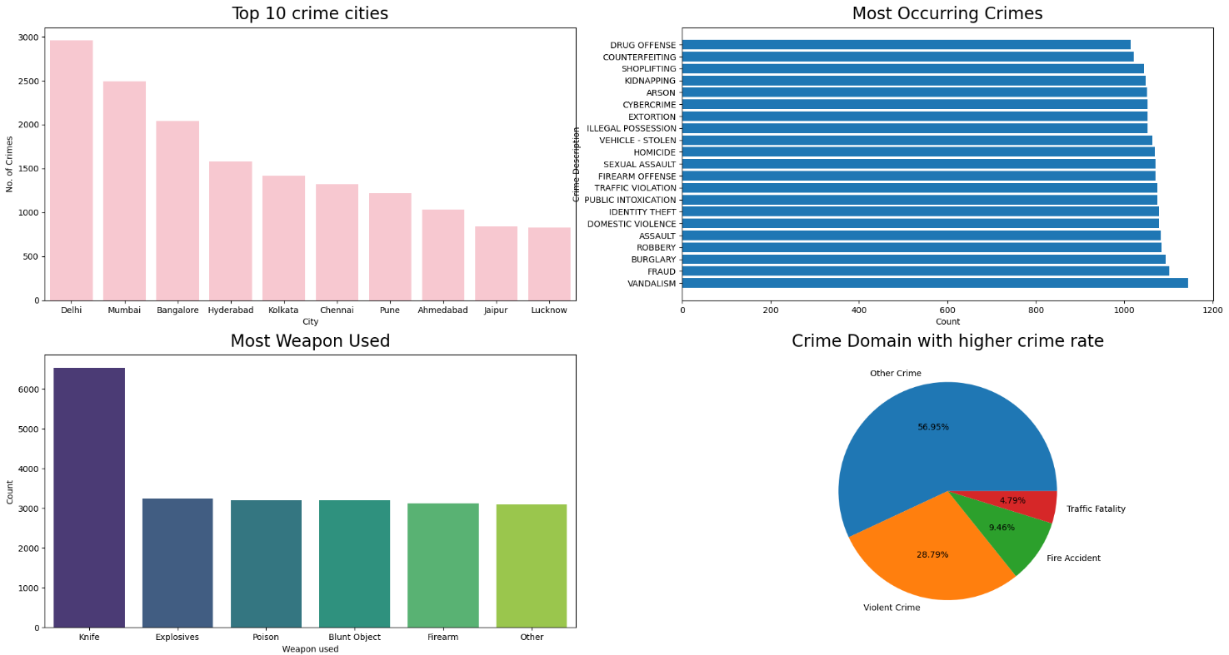
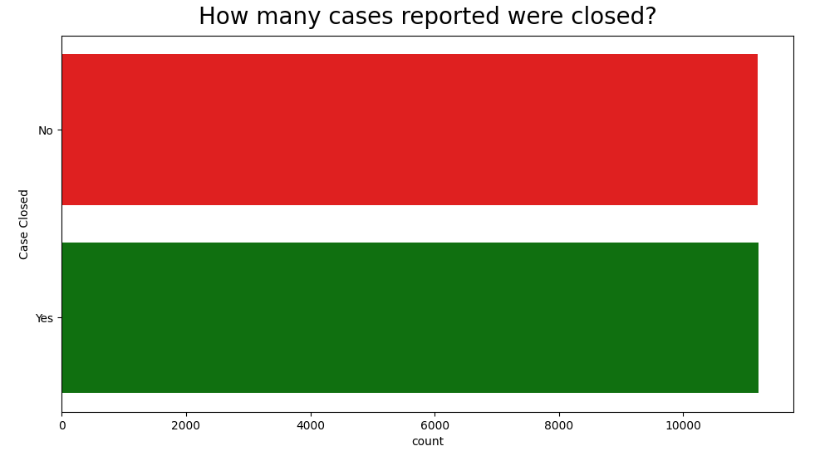

FIG. 2 - Top 10 Crime Cities; Most Occurring Crimes; Most Common Weapons Used; Crime Domain Distribution; Case Closure Rate

Bivariate Analysis

Bivariate analysis was performed to assess the connections between all variables associated with time, categorical aspects, and outcome-oriented aspects of the dataset. The analysis offered timely observations, such as: temporal differences in patterns of crime; area differences at the city level; and time and other variable effects on the counts of reported crime and case closures/rate of clearance.

I Crime Trends by Month and Year
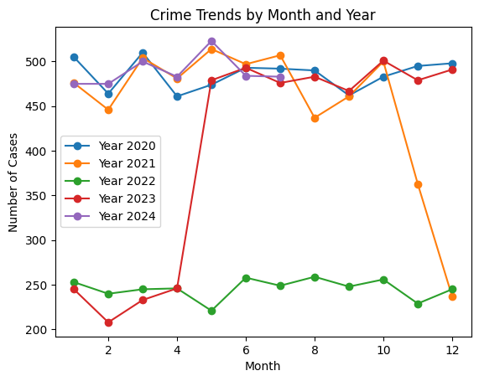
FIG.3 - Crime Trends by Month and Year
- The yearly trend shows clear temporal variability regarding reported crime: 2020 and 2024 each show consistently elevated cases of crime each month of the year with cases averaging 470–520 reported crimes per month.
- In 2021 there are more high reported counts at the beginning of the year, but then the number of reported crimes declines sharply during the months of November and December, either as a correlation to enforcement improvements, or seasonal decline in crime.
- 2022 shows the lowest overall volume of reported crime across the year between 220–260 cases/month, indicating either reporting deficiencies or evidence of decreases in a crimes across cities and with engagement across police/society.
- 2023 shows an anomalous pattern; there we see a period of low crime reports prior to the month of April and then we see a dramatic spike after April that goes through the rest of the year staying just above 480 reported crimes per month.
- Inference: Crime events appear to be somewhat cyclical, however, most years exhibit distinct peaks in crime reported in the months of March–May and October; at the same time that supports reasonable concerns over seasonality and situational factors of crime associated with the environmental and social context.

II How Different Crime Types Get Resolved
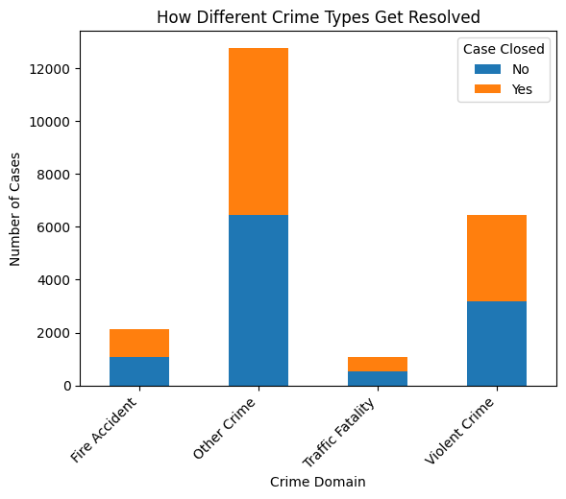
FIG.4 - How Different Crime Types Get Resolved
- Other Crimes provide the highest rate of cases, but a large portion of these cases are unresolved, possibly due to vague categorization or complicated investigations.
- Violent Crimes have better rates of closure than Other Crimes, but these crimes add considerable volume to the case load that is unresolved.
- Fire Accidents and Traffic Fatalities have a low incidence of cases overall and higher closure rates for these cases, which could mean that there is less ambiguity or complexity in the detective work that was needed to close the case.
- Inference: Case closure is vastly more variable by type of crime, suggesting there are potential differences in justice or criminal procedures.

III Crime Frequency by Hour & Month
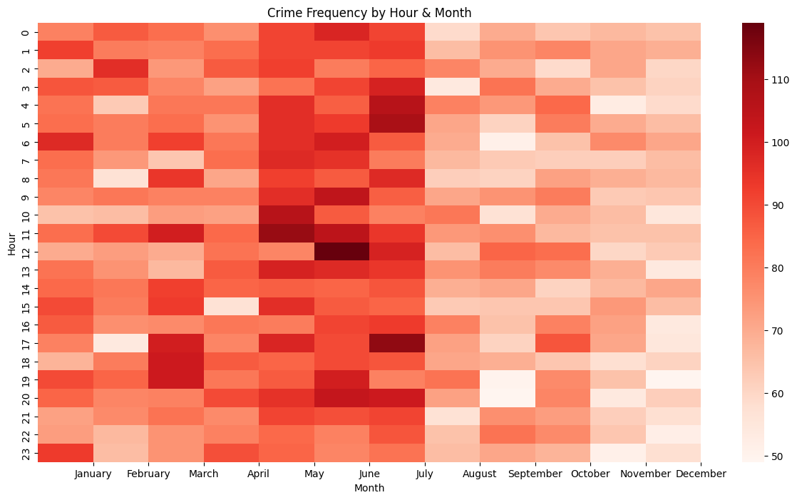
FIG.5 - Crime Frequency by Hour & Month
Crime counts are closely related on time:
- Crime peaks are from 10:00am to 2:00pm, and again in the early evening - suggesting there is simply more risk for exposure during team or work activities.
- The midday and early evening times have consistently more crime during this time frame (when compared with late night).
- May - June marks the highest number of months for crime, this could likely fit with annual heat months and increased public activity.
- August - November represents a low amount of activity, marking the lowest time period during the year.
Inference: Crime is more likely to occur during the hours of decent daylight and before monson months, indicating potential linkages with the movement of people and exposure outdoors.

  - Machine Learning Models

    - Decision Tree : It is an information delineation structure comprising of hubs and branches composed inside the sort of a tree indicated, each inner non-leaf hub is labelled with estimations of the traits. The branches setting out from an encased hub are labelled with estimations of the characteristics in the hub. Each hub is labelled with a class (characteristic value). For the most part models that grasp grouping are the primary procedure of acceptance displaying, choice fitted to information handling. There are in profitable to build, simple to decipher, simple to incorporate with Database framework and they have practically identical or better precision in numerous applications.

    - Random Forest Classification Model : Random forests or random decision forests are an ensemble learning method for classification, regression and other tasks that operate by constructing a multitude of decision trees at training time and outputting the class that is the mode of the classes (classification) or mean/average prediction (regression) of the individual. Ensemble learning method combines various base models in order to produce one predictive model which is optimal and more powerful.

    - XG Boost Classification Model: It is based on the concept of gradient boosting. It also makes use of decision trees. It is a custom, parallelized tree building algorithm which contains several decision trees. It provides features like efficient handling of missing data, and automatic feature selection.

    - K-Means Clustering: K-means clustering is an unsupervised machine learning algorithm used to partition a dataset into a pre-defined number of clusters, denoted by 'k'. The algorithm aims to group data points that are similar to each other into the same cluster, while keeping dissimilar data points in different clusters.

  - Evaluation Metrics
Various evaluation metrics have been used such as accuracy; F1 score, precision, recall, root mean square error, and R² score to test the performance of the applied machine learning models. Each one f them has been discussed briefly below:
Accuracy: The percentage of predicted values that match actual values is calculated by accuracy and is shown in Eq.(1) .
𝐴𝑐𝑐 = $\frac{True Positive + True Negative}{True Positive+True negative+False Positive +False Negative}$ [1]

F1 Score: It is used to assess the authenticity of a test. The Harmonic Mean of precision and recall is the F1 Score which has ranges between 0 and 1. It tells you how accurate and how robust our classifier is . It is calculated by Eq. (2).
𝐹1 𝑆𝑐𝑜𝑟𝑒 = $\frac{2 Precision*Recall}{Recall+Precision }$ [2]

Precision: It is the number of positive classifiers divided by the total number of positives both true as well as false number of correct positive outcomes.. It is calculated by Eq.(3).
𝑃𝑟𝑒𝑐𝑖𝑠𝑖𝑜𝑛 = $\frac{True Positive + True Negative}{True Positive+False Positive}$ [3]

Recall: The number of rational positive results divided by total relevant samples . It is calculated by Eq(4).
𝑅𝑒𝑐𝑎𝑙𝑙 = $\frac{True Positive }{True Positive+False Negative}$ [4]

Root mean square error: Euclidean distance uses to indicate how far predictions differ from true measured values. It is one of the most widely used criteria for assessing the accuracy of predictions. The root mean square error is calculated by Eq.(5).

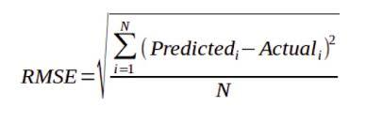 [5]

R² score: It is known as coefficient of determination. It is the proportion of the variance in the dependent variable that is forecasted from the independent variable(s) and is calculate by Eq(6).
𝑅² = 1 − $\frac{SSres}{SSerr}$ [6]

where SSres is the residual sum of squared errors and SSerr is the total sum of squared errors.

- Results
This section will discuss the results of three machine learning methods - Classification, Regression, and Clustering. Each method had a different focus analytic for the study. Results will be reported in a quantitative fashion using model performance measures, as well as in a visual way using graphs and charts for better understanding.

Classification Results
After the preprocessing stage - that involved data cleaning, categorical variables encoding and numerical columns scaling - a more in-depth exploration of the data was conducted to investigate the relationships between variables that might impact model performance. A correlation heatmap was created to explore the linear relationship between the input and target variables. The heatmap analysis indicated that the target variable (Case Closed) had weak linear correlations with most of the training variables such as City, Crime Domain, and Weapon Used. This indicated that a linear model would not be able to adequately represent the relationships present and prompted the use of non-linear classification algorithms instead such as Decision Tree, Random Forest and XGBoost classification models to determine if a presented crime case would close or remain unresolved

(i)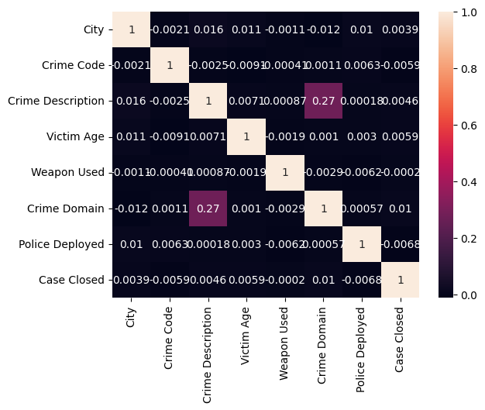 (ii) 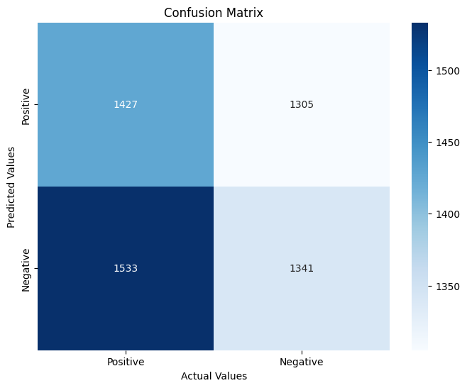
(iii) 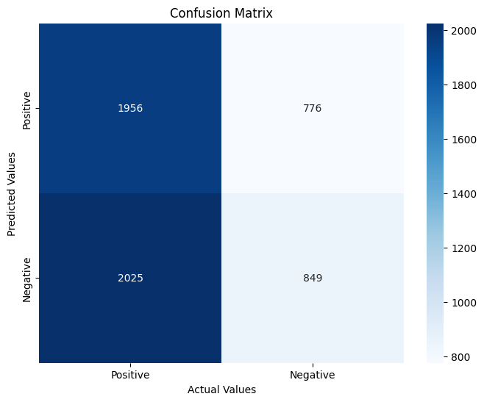 (iv)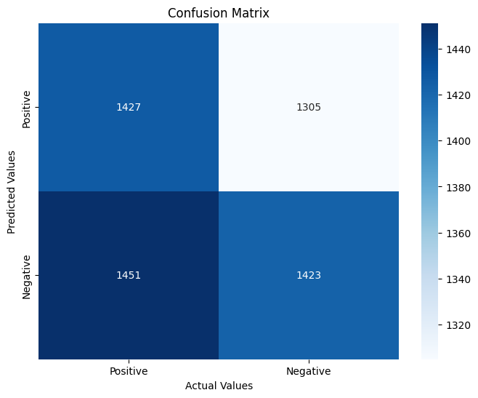
FIG.6 – (i)Correlation Heatmap; (ii) Confusion Matrix of Decision Tree;
(iii) Confusion Matrix of Random Forest; (iv) Confusion Matrix of XG Boost

Three models were trained and evaluated on the same dataset split for fair comparison. Their performance metrics — accuracy, precision, recall, and F1 score — are summarised in Table1. Confusion Matrices generated for all three models are shown in Fig.(6).

Model | Accuracy Score (%) | Precision  (%) | Recall  (%) | F1 Score  (%)
Decision Tree | 50.35 | 50.68 | 46.65 | 48.58
Random Forest | 50.03 | 52.24 | 29.54 | 37.74
XG Boost | 50.84 | 52.16 | 49.51 | 50.8
Table 2

Out of the three models, XGBoost provided the most consistent performance across all metrics, attaining the highest F1 score (50.8%) meaning it was able to achieve a better balance between precision and recall. The Decision Tree model performed somewhat adequately. Initially, it showed an overfitting with training data accuracy higher than testing data accuracy, which was then addressed by pruning. Random Forest produced a decrease in recall, suggesting it was underfitting and/or highly sparsified features due to low linear separability of the dataset. For increasing the accuracy score , Hyperparameter tuning was also performed by leveraging both Grid Search as well as randomised search.
Overall, the relatively small differences between the models demonstrate that there was a subtle class separation in the dataset, and the variables were dominated by categorical, weakly correlated variables. The non-linear models, specifically XGBoost, were better able to model these subtle non-linear dependencies than the ensemble or single trees.

Regression Results
The regression component of this work sought to explore temporal and spatial patterns impacting the dynamics of crime and the time to resolution. Two distinct regression tasks were completed: (1) Assessing the number of days until a case was closed, and (2) Estimating the number of crimes across the city in a given month. For the first regression task, a Decision Tree Regressor was used to predict the Days to Close variable. The decision tree model was initially overfitting, indicated by the training performance being substantially better than the test performance. Upon review of the decision tree parameters, the models were pruned additional considerations of maximum depth were introduced to the leaf decision criteria, which eliminated the overfitting condition and improved generalisation of the model. Once the pruning was completed, the outcome measures were as follows:
Accuracy: 80.45%

Mean Absolute Error (MAE): 33.52
Mean Squared Error (MSE): 3231.71
R² Score: 80.44%
This was a favourable result as the model captured most of the variance in case resolution time, although we can never truly predict everything beyond the recorded features in our dataset. For the second regression task, a regression model was utilised to predict the number of crimes per city, per month, using temporal and geographic indicators. The performance of the model was significantly better than the first regression task, with outcome measures as follows:
Accuracy: 94.71%

Mean Absolute Error (MAE): 10.47
Mean Squared Error (MSE): 190.60
R² Score: 94.71%.
This substantial R² value clearly illustrates that the model was effective at capturing periodic and locational crime patterns. The data indicate that monthly and city-level characteristics are important in determining the distribution of crimes, making this a reliable model for predicting crime rates by cities.

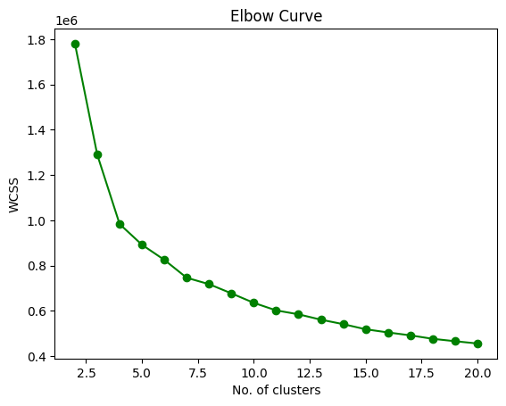
K-Means Clustering Results
K-Means clustering was used to discover latent patterns for crime based on the temporal and spatial distribution of crime, which included features such as City, Crime Domain, Month, Day of Week, and Hour of Occurrence. Using the Elbow Method, the best number of clusters (k=4) was derived empirically, with little variance within cluster locations and some distance between neighbours.
FIG.7 – Elbow method
Findings and Interpretation
The clustering process revealed distinct clusters of behaviour and geography, with strong contributions from City and Time of Occurrence. In contrast, we discovered that Crime Domain and Year did not offer much in explaining the distinction in the clusters, reflecting that the temporal–spatial dimension was the strongest contributor to patterns forming from the dataset.
The insights derived from the cluster analysis are summarised below: Temporal and spatial organisation: Clusters were most distinct when analysed against hour and city, which confirms crime patterns of occurrence were both time and location-based.
The clusters containing Codes 0 and 3 occurred between 12 AM to 10 AM, which can be defined as a 'greatly early' time of day. Clusters containing Codes 1 and 2 occurred primarily between 10 AM to 12 AM, which can be defined as afternoon and late evening behaviour.
The clusters containing Codes 0 and 3 represent cities 0 - 10. The clusters for Codes 1 and 2 are prevalent in cities 10 - 30. For example, Delhi (City 5) and Mumbai (City 17) were strong contenders, emerging hubs, but distinctly different times with quite different clustering of days in the week.
- Summaries of Clusters:

Cluster 0 — Low-intensity routine crimes
- Appears across most cities and times
- Crime Domain mostly: 0–1 (petty theft, minor quarrels, disputes)
- Very broad spread across hours/days → background crime noise
- This cluster represents baseline risk in all locations

Cluster 1 — High-intensity & time-targeted crimes
- Crime Domain strongly: 2–3
- Tends to occur in distinct time windows
- Concentration observed regardless of city → method-specific crimes
- Suggests offenders follow predictable windows (planned crimes)

Cluster 2 — Mixed-risk opportunistic crimes
- Crime domain is mixed (1–2)
- Spread out evenly across day/week/month
- Weak patterns → opportunistic behavior
- Hotspots form due to density + opportunity, not planning

Cluster 3 — Recurrent seasonal hotspot crimes
- Distinct month spikes (visible around month 6 in your plot)
- Crime Domain: mostly 1
- Suggests crimes that increase due to:
  - Climate
  - Festivals / events
  - School/college cycles
  - Tourism seasons
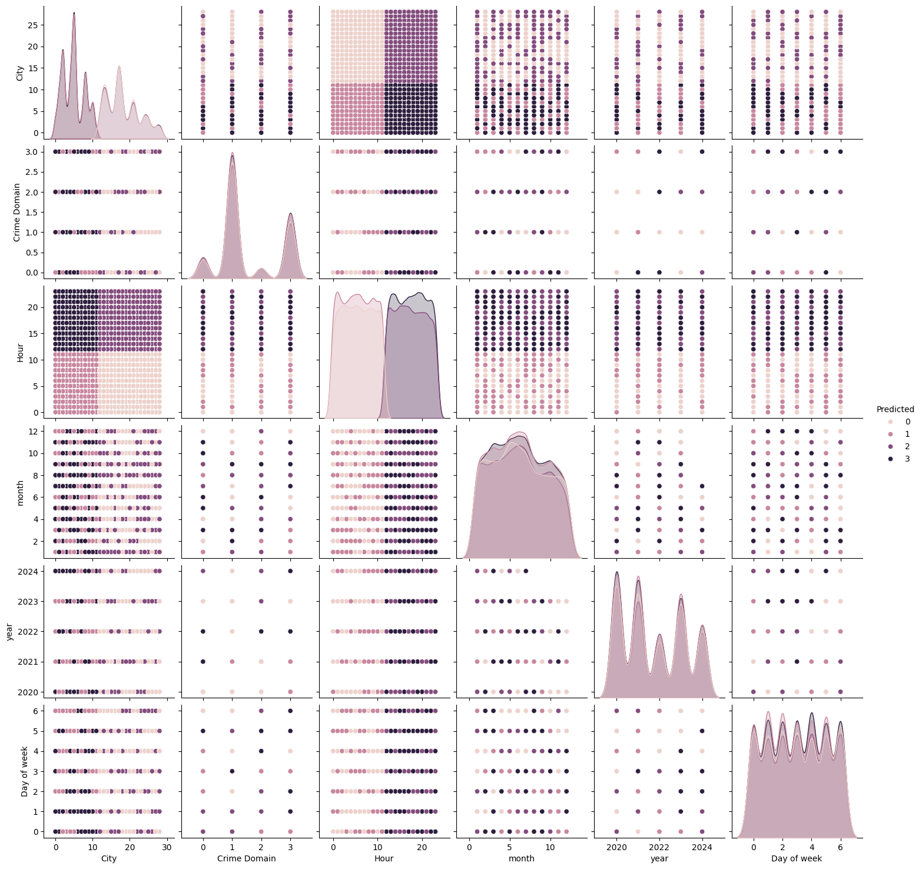
FIG.8 – Cluster Pattern

- Challenges and Limitations

This study experienced a number of challenges. The dataset exhibited missing values and inconsistencies in crime type formats, necessitating a significant amount of pre-processing. The regression model faced issues of overfitting, which we dealt with using a pruning method. Furthermore, there was a weak correlation between the independent variable and target variable, yielding overall classification accuracy that was somewhat limited. That said, the models revealed significant trends in crime patterns in both time and space.

6 Conclusion
This research aimed to analyze and predict crime patterns against women in India using a combination of classification, regression, and clustering techniques. The classification techniques (Decision Tree, Random Forest, and XGBoost) were moderately predictive overall; XGBoost was better than the others in classification, suggesting that nonlinear ensemble models may provide better predictive power for this small, but complex, dataset. Both regression models appear to have properly estimated days to close a case, as well as the crimes per city per month, with good explanatory power based on pruning and tuning. The clustering method using K-Means indicates that there are distinct patterns and trends in crime based on time, city, and season, notwithstanding the trends based on crime type. Overall, this work suggests that machine learning may establish more of a role as a decision-support tool in crime analysis, prevention, and formulation of policy, particularly with court and enforcement data as advocates. Future work to strengthen this would benefit from expanding the data set beyond the sample size and improving the generalizability of the models using deep learning methods, as well as implementing visual dashboards for agencies to use in real-time. We can also build on this work by utilizing ARIMA and SARIMA forecasting models to assess temporal trends and find emerging crime hotspots, ultimately improving real-time crime prevention and allocation of resources.

7 References

- Kaggle. “Indian Crimes Dataset” Available at: https:/www.kaggle.com/datasets/sudhanvahg /indian-crimes-dataset%20(Accessed on 13 November 2025).

- J. A. Islam and M. Saikia, “Exploring Crime Against Women in India: Socio-Economic and Spatial Trends,” Pressto, Adam Mickiewicz University Press, 2025.
Available at: https://pressto.amu.edu.pl/index.php/sr/article/view/47732

- T. Saxena, “Crimes Against Women in India: Trends, Challenges, and Empirical Insights,” SPRF India, 2024.
Available at: https://sprf.in/crimes-against-women-in-india-trends-challenges-and-policy-responses/

- N. U. Islam and A. H. Wagay, “Addressing Violence and Rape Against Women in India: Statistical Realities and Interventions,” SAGE Journals, 2025.
DOI: 10.1177/26318318251326165

- Smile Foundation, “Crimes Against Women in India: Types, Trends, and Policy Gaps,” 2025.
Available at: https://www.smilefoundationindia.org/blog/crimes-against-women-in-india-types-trends-and-empowerment/

- S. Kumari, N. Kumar, and A. Sharma, “Mapping the Dynamics of Crime Against Women in India,” OpenEdition Journals, 2025.
Available at: https://journals.openedition.org/belgeo/75083

- M. Aggarwal, “Prediction and Analysis of Crime Against Women in India using Machine Learning Techniques,” Google Colab Notebook, 2025.
Available at: https://colab.research.google.com/drive/12eb2I7azlrIzeDV50FFZR2j0Won7HnsF?usp=sharing— Accessed on: 13 November 2025.

